School Counseling Program Newsletter
Shandrai Silva, School Counselor | May 2019

Counselor Message  Wow! It’s hard to believe we’re coming close to the end of another school year. With summer break quickly approaching, let’s commit ourselves to ending the school year strong- academically and interpersonally.  In April, our students participated in Career Day. Career Day is an awesome way for our students to connect their exploration and learning about college and careers to real world experiences. There were approximately 40 companies/businesses represented at Career Day. Students learned about STEAM related careers and engaged in career and college related activities throughout the school day.  The School Counseling program is pleased with our accomplishments this school year- guidance lessons on a variety of topics, school-wide service projects, recognition of and school participation in special events like International Dot Day, Bullying Prevention Month, Red Ribbon Week, No Name-Calling Week, Great Kindness Challenge, GCS Mental Awareness Week and facilitation of individual and small group counseling.  Have a great time this summer with family and friends- enjoy each other and make a lot of fabulous memories?  How to See the School Counselor  Classroom guidance classes biweekly based on  grade levels schedule. Small group and individual  counseling by self -referral, parent referral, teacher  referral, administrator referral or counselor  initiated.  Contact School Counselor at 704-866-8467 or  sosilva@gaston.k12.nc.u | Home of the Hawks    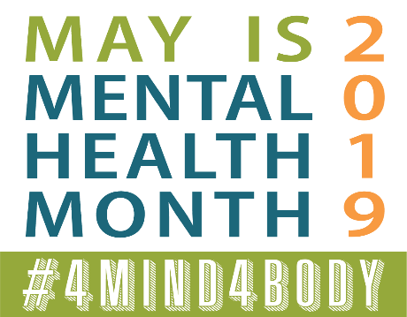  http://www.mentalhealthamerica.net/  https://www.nami.org/  Teacher Appreciation Week  &  National Nurse’s Week  (National School Nurse Day- May 8th)  Thank You for your commitment  to the students at  Hawks Nest STEAM Academy! | Character Education  “We’re Soaring with Good Character”  _____________________________  The character trait of the month is Courage. Courage is doing the right thing even when others don't; following your conscience instead of the crowd; and attempting difficult things.  ________________________________  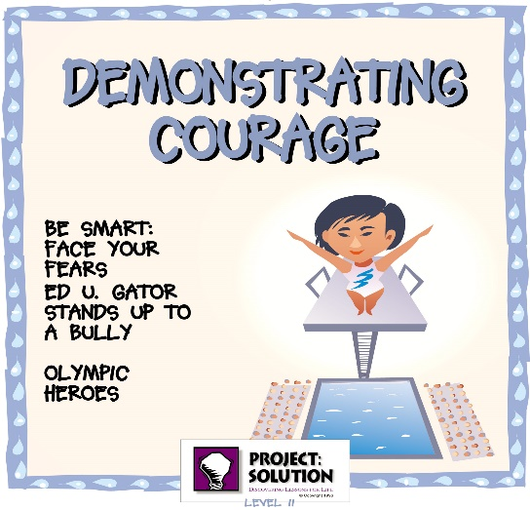  https://nierocks.areavoices.com/2012/07/05/character-education-series-courage/  What courage is all about …  Trying to do the best that you can do, even when you’re afraid.  Being smart and making the right choices.  Trying hard and doing the right thing.  https://nierocks.areavoices.com/2012/07/05/character-education-series-courage/  “Intelligence plus character- that is the goal of true education.”  Dr. Martin L. King, Jr.

